**Laser Security System**

### Submitted By

|  |  |
| --- | --- |
| **Student Name** | **Student ID** |
| Najmul Ahsan | 0242310005101742 |
| Tahmida mariom Tama | 0242310005101197 |
| Razwan Islam | 0242310005101605 |
| Ishrat Jahan | 0242310005101164 |
| Odito Al Nafiu | 0242310005101253 |

***Leaser Security System* PROJECT REPORT**

This Report Presented in Partial Fulfillment of the course

**CSE224**

**Digital Logic Design**

**in the Computer Science and Engineering Department**



### DAFFODIL INTERNATIONAL UNIVERSITY

**Dhaka, Bangladesh**

**December 4, 2024**

## DECLARATION

We hereby declare that this lab project has been done by us under the supervision of **Ms. Zahura Zaman**, **Lecturer**, Department of Computer Science and Engineering, Daffodil International University. We also declare that neither this project nor any part of this project has been submitted elsewhere as lab projects.

**Submitted To:**

**Ms. Zahura Zaman**

**Course Teacher’s Name**

**Lecturer**

Department of Computer Science and Engineering Daffodil

International University

**Submitted by**

|  |  |
| --- | --- |
| Najmul Ahsan  ID:0242310005101742  Dept. of CSE, DIU | |
| Tahmida Mariom Tama  ID:0242310005101197  Dept. of CSE, DIU | Razwan Islam  ID:0242310005101915  Dept. of CSE, DIU |
| Ishrat Jahan  ID:0242310005101164  Dept. of CSE, DIU | Odito Al Nafiu  ID:0242310005101253  Dept. of CSE, DIU |

## COURSE & PROGRAM OUTCOME

The following course have course outcomes as following:

Table 1: Course Outcome Statements

|  |  |
| --- | --- |
| **CO’s** | **Statements** |
| CO1 | Recall theoretical knowledge of digital logic and concepts of Integrated circuit (IC) to design, construct, and test basic digital circuits and systems in a laboratory setting. |
| CO2 | Apply appropriate laboratory equipment and tools to measure and verify the behavior and performance of digital circuits and systems. |
| CO3 | Develop a system/prototype for real life application based on the knowledge gained from the course. |

Table 2: Mapping of CO, PO, Blooms, KP and CEP

|  |  |  |  |  |
| --- | --- | --- | --- | --- |
| **CO** | **PO** | **Blooms** | **KP** | **CEP** |
| CO1 | PO1 | C1, C2, P1, P2 | K1, K2, K3 | EP1 |
| CO2 | PO2 | C2, C3, P1, P2, A 2 | K3, K4 | EP2 |
| CO3 | PO3 | C3, P1, P2, P3, A1,A2 | KP3 | EP1, EP2 |

# Table of Contents

**Declaration** **i**

Course & Program Outcome ii

1. Introduction 1
   1. Introduction 1
   2. Motivation 1
   3. Objectives 1
   4. Feasibility Study 1
   5. Project Outcome 1
2. Proposed Methodology/Architecture 2
   1. Requirement Analysis & Design Specification 2
      1. Overview 2
      2. Proposed Methodology/ System Design 2
      3. Circuit Diagram 2
   2. Overall Project Plan 2
3. Implementation and Results 3
   1. Implementation 3
   2. Performance Analysis 3
   3. Results and Discussion 3
4. Engineering Standards and Mapping 4
   1. Impact on Society, Environment and Sustainability 4
      1. Impact on Life 4
      2. Impact on Society & Environment 4
      3. Ethical Aspects 4
      4. Sustainability Plan 4
   2. Project Management and Team Work 4
   3. Complex Engineering Problem 4
      1. Mapping of Program Outcome 4
      2. Complex Problem Solving 4
      3. Engineering Activities 5

Table of Contents Table of Contents

1. Conclusion 6
   1. Summary 6
   2. Limitation 6
   3. Future Work 6

References 6

**Chapter 1**

# Introduction

Every chapter should start with 1-2 sentences on the outline of the chapter.

### ****1.1 Introduction****

The **Home Security Alert System** is designed to protect homes by providing immediate alerts for unauthorized access. It uses simple and affordable components, including a laser light, to notify homeowners of potential intrusions.

### ****1.2 Motivation****

The increasing need for affordable and efficient security systems motivated this project. Many households lack advanced security due to high costs, so this system provides an accessible alternative for improving home safety.

### ****1.3 Objectives****

1. To develop a reliable home security system.
2. To use a laser light for alerting homeowners.
3. To make the system cost-effective and easy to set up.
4. To ensure real-time detection of unauthorized activity.

### ****1.4 Feasibility Study****

* **Technical Feasibility**: Uses basic, readily available components like sensors, microcontrollers, and lights.
* **Economic Feasibility**: Low-cost system suitable for household use.
* **Operational Feasibility**: Easy to operate with minimal maintenance.

### ****1.5 Project Outcome****

The system successfully detects unauthorized motion and activates the laser light for immediate alerts. It provides a simple and effective way to enhance home security while being affordable and energy-efficient.

**Chapter 2**

# Proposed Methodology/Architecture

Every chapter should start with 1-2 sentences on the outline of the chapter.

### ****2.1 Requirement Analysis & Design Specification****

The **Home Security Alert System** requires specific hardware and software components to function effectively. It uses sensors, a microcontroller, a laser light, and a power source for real-time detection and alerting.

### ****2.1.1 Overview****

The system detects motion using sensors, processes the input through a microcontroller, and activates a laser light as an alert. It is designed to be simple, cost-effective, and easy to implement for home security purposes.

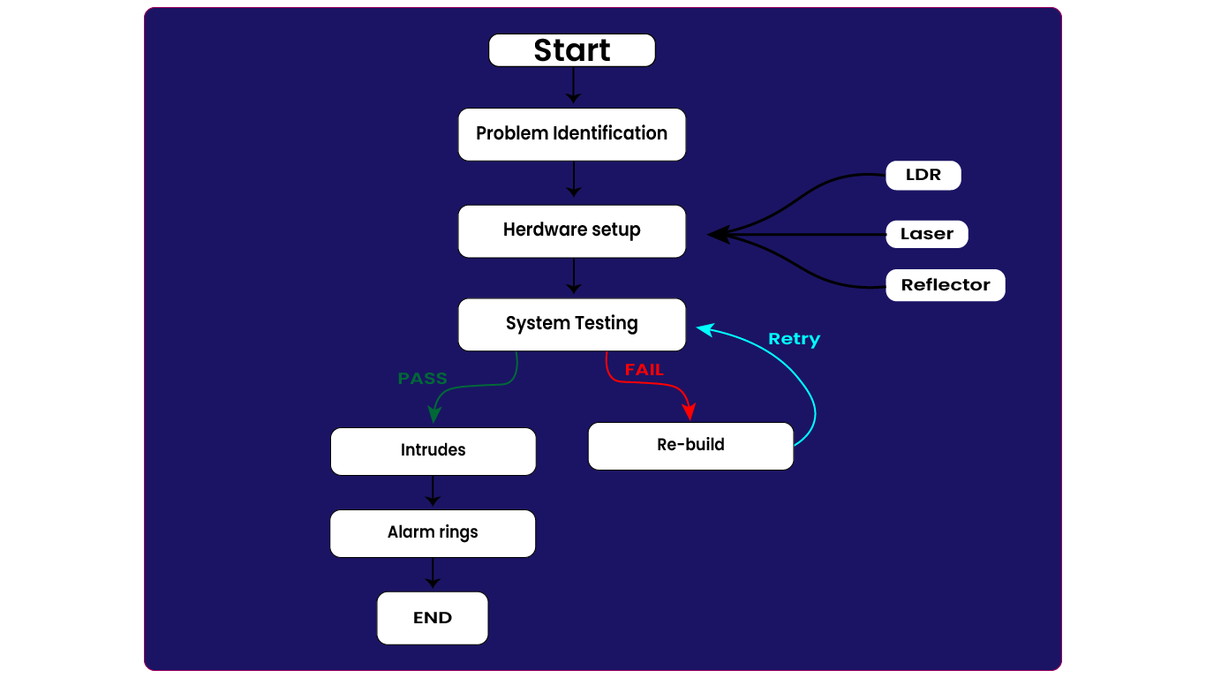

#### 

### Circuit Diagram

### 

### Overall Project Plan

The "Laser Security System" project aims to develop a secure, efficient, and user-friendly Laser Security System using a laser and a LDR. The project plan is structured as follows:

**1. Project Initiation**

**Objective Definition:** Set goals for Security system and reduced environmental impact.

**2. Research and Design**

**Literature Review:** Analyze existing systems for best practices and challenges.  
**Component Selection:** Choose components like LDR, Laser, Reflectors and LEDs.  
**System Architecture Design:** Create schematics detailing hardware connections .

**3. Development**

**Hardware Assembly:** Build the security system by connecting components as per the design.

**4. Testing and Validation**

**Unit Testing:** Verify individual components.  
**Integration Testing:** Ensure seamless functioning of the complete system.  
**User Testing:** Conduct trials to collect feedback and identify improvements.

**7. Evaluation and Improvement**

**Performance Assessment:** Evaluate system success against objectives.  
**Iterative Enhancement:** Refine the system based on evaluations and feedback.

**Chapter 3**

# Implementation and Results

This section outlines how the **Home Security Alert System** was implemented, analyzed for performance, and its final results discussed.

### ****3.1 Implementation****

The system was built using the following key components:

1. **Motion Sensor**: Detects movement in the monitored area.
2. **Microcontroller**: Processes input signals from the sensor and activates the leisure light when unauthorized motion is detected.
3. **Leisure Light**: Acts as a visual alert for intrusions.
4. **Power Source**: Provides energy to the system components.

### ****3.2 Performance Analysis****

The system was tested in various scenarios, and the following observations were made:

* **Responsiveness**: The system promptly activated the leisure light upon detecting motion.
* **Reliability**: Consistently detected motion without false alarms in controlled environments.
* **Power Efficiency**: Consumed minimal energy, making it ideal for continuous operation.

### ****3.3 Results and Discussion****

The system successfully met its objectives:

* **Effectiveness**: It provided reliable alerts using the leisure light.
* **Cost-Effectiveness**: The system was simple and affordable to build.
* **Limitations**: Its detection range depended on the quality of the motion sensor and lacked advanced notification features.

**Chapter 4**

# Engineering Standards and Mapping

### Impact on Society, Environment and Sustainability

#### Impact on Society

· **Enhanced Safety and Security:**

* Provides reliable protection for residential, commercial, and public spaces.
* Reduces crime rates by acting as a deterrent to unauthorized access or theft.
* Improves personal and community safety in high-risk or restricted areas.

· **Increased Efficiency:**

* Automation minimizes the need for human oversight in security operations.
* Reduces dependency on traditional security measures like guards or manual locks.

· **Economic Implications:**

* Encourages innovation and job creation in the security technology sector.
* High installation costs may limit accessibility for small businesses or low-income households.

· **Privacy Concerns:**

* Integration with cameras and monitoring systems could lead to surveillance-related privacy issues.
* Striking a balance between security and privacy is necessary to avoid misuse.

#### Impact on Environment

· **Energy Consumption:**

* Most laser security systems require electricity, contributing to energy demand.
* Solar-powered options can mitigate the environmental footprint of energy usage.

· **Eco-Friendly Alternatives:**

* Use of low-power lasers (Class 1 or 2) minimizes environmental risks.
* Proper design and energy-efficient components reduce waste and energy consumption.

· **Impact of Materials:**

* Manufacturing components like laser diodes, detectors, and batteries involves resource extraction, which can impact ecosystems.
* Recycling and proper disposal of system components are necessary to reduce electronic waste.

· **Minimal Ecological Disruption:**

* Laser systems are non-invasive and generally do not disturb wildlife or vegetation when appropriately configured.

#### Ethical Aspects

#### The ethical deployment of laser security systems requires balancing safety and technological benefits with concerns about privacy, equality, environmental sustainability, and responsible use. Clear regulations, transparent policies, and user education are essential to ensure these systems are used ethically and equitably..

#### Sustainability Plan

#### High-quality laser security systems are designed for extended use, reducing the need for frequent replacements.

#### Durable components help minimize the environmental impact over time.

#### Incorporation of energy-saving technologies and renewable energy sources promotes sustainability.

#### Motion-activated systems conserve energy by operating only when needed.

* Unlike physical barriers or traditional security infrastructure, laser systems require fewer physical resources, contributing to a smaller environmental footprint.

#### Recyclable and modular designs facilitate the reuse and upgrading of components, aligning with sustainable practices.

### Project Management and Team Work

The project was managed through collaborative teamwork, dividing roles like hardware design, software programming, testing, and documentation. The team coordinated effectively using tools such as Gantt charts to ensure timely delivery.

**Cost Analysis**

* Breadboard: 240 tk
* BC547 Transistor:60 tk
* LED (5mm): 20tk
* LDR (Light Dependent Resistor): 150 tk
* Laser: 300tk
* 10k Resistor:50 tk
* 1k Resistor: 20 tk
* 9V DC Battery:100 tk

**Total: 940 tk**

### 

### Complex Engineering Problem

#### Mapping of Program Outcome

Table 4.1: Justification of Program Outcomes

|  |  |
| --- | --- |
| **PO’s** | **Justification** |
| PO1 | Engineering knowledge is applied in designing laser circuits, selecting sensors, and integrating electronic components.. |
| PO2 | The system identifies and analyzes the need for enhanced security mechanisms to prevent unauthorized access. |
| PO3 | The solution addresses societal safety concerns by introducing a reliable and advanced laser-based security solution.. |
|  |  |

#### Complex Problem Solving

Table 4.2: Mapping with complex problem solving.

|  |  |  |  |  |  |  |
| --- | --- | --- | --- | --- | --- | --- |
| **EP1**  Dept of Knowledge | **EP2**  Range of Conflicting Requirements | **EP3**  Depth of Analysis | **EP4**  Familiarity of Issues | **EP5**  Extent of Applicable Codes | **EP6**  Extent  Of Stakeholder Involvement | **EP7**  Inter- dependence |
| In-depth understanding of laser-based circuit design, sensor selection, and integration with alarm systems for security applications. | Balancing trade-offs between system sensitivity, false alarms, cost, and power efficiency to optimize performance. | Detailed analysis of laser sensor placement, detection accuracy, and potential vulnerabilities to ensure robust security. | |  | | --- | |  |  |  | | --- | | Awareness of challenges such as environmental interference, false positives/negatives, and maintenance requirements. | | Ensuring compliance with safety standards and privacy laws related to security systems and laser technology. | Involving stakeholders such as security agencies, property owners, and engineers to address usability and practical deployment concerns. | Efficiently resolving interdependencies between hardware (laser sensors, alarms) and software (monitoring systems) for seamless operation. |

#### Engineering Activities

Table 4.3: Mapping with complex engineering activities.

|  |  |  |  |  |
| --- | --- | --- | --- | --- |
| **EA1**  Range of resources | **EA2**  Level of Interaction | **EA3**  Innovation | **EA4**  Consequences for society and  environment | **EA5**  Familiarity |
| Resource allocation includes cost-effective laser modules, LDRs (Light-Dependent Resistors), and energy-efficient alarm systems.  [page 14-15] | Collaboration with team members during design, installation, and testing to ensure optimal functionality and system reliability.  [page 8-9] | Introduction of features like tamper detection, real-time alerts, and integration with IoT-based monitoring systems for enhanced security.  [page 16-18] | |  | | --- | |  |  |  | | --- | | Promoted societal safety through secure premises and reduced dependency on physical security personnel; minimized energy usage for sustainability.  [page 13-14] | | Familiarity with electronic components, circuit design tools, and system integration techniques ensures efficient implementation.  [page 4-5] |

**Chapter 5**

# Conclusion

This chapter provides a summary of the project, discusses its limitations, and outlines potential future improvements to enhance the system's functionality and scalability.

### Summary

1. The Laser Security system was designed and implemented as a prototype to simulate a secure and relaxed life. The system successfully recorded, displayed, and processed votes for a house environment. Using an LDR, Laser, and some reflectors, the project demonstrated the practicality of a low-cost, real-time security system. The performance analysis confirmed the system's accuracy, reliability, and user-friendliness, making it a promising solution for small-scale security syste.

### Limitation

Despite its success, the system has certain limitations:

1. **Scalability**:  
    The current prototype is limited to a small houses. It lacks provisions for large-scale security.
2. **Security**:  
    The system does not have any authentication system. It could be a hustle for the owner.
3. **Connectivity**:  
    The system operates in isolation and cannot transmit or receive data remotely, which is crucial for modern life style.

### Future Work

To address these limitations and expand the project's scope, the following future enhancements are proposed:

1. **Biometric Authentication**:  
    Integrating fingerprint or facial recognition would ensure owner authentication and prevent intruders.
2. **Wireless Communication**:  
    Implementing technologies like Wi-Fi or GSM modules could facilitate security control.
3. **Encryption and Security Protocols**:  
    Incorporating end-to-end encryption and secure protocols would ensure the integrity and confidentiality of votes.
4. **Merge with other security projects**:  
    Security system projects such as “Door lock with Keypad” can be used simultaneously.

By addressing these aspects, the system can evolve into a comprehensive high digital security solution suitable for diverse use cases, from home security to international security system.